**Horseshoe crabs,** Xiphosura or Merostomata

**Spend a few minutes learning about horseshoe crabs from the background material provided in the “read before lab” material on arthropod groups.**

**With your instructor’s help, examine the specimens of horseshoe crabs available.**

**Below are some diagrams to help you. Simply use this lab to get a better feel for how they move and locomote. These are young animals. You will not be able to tell males from females. Your teaching assistant if asked politely will demonstrate feeding in this group. If you place a piece of food between their walking legs above the chilarium, they will happily feed for you. The chilarium, a pair of modified appendages, prevents the escape of food. Often they will feed even if held upside down. Or one can start them feeding right side up and then turn them upside down to better observe feeding. These critters like small chunks of shrimp, etc. to feed on.**

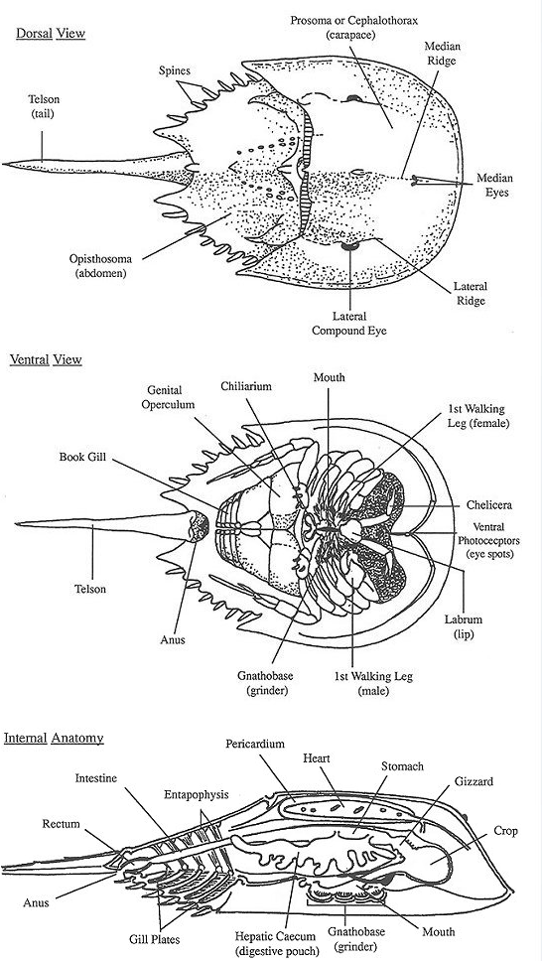

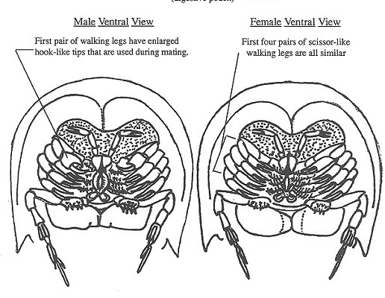

Place food here.